

NAME: NOSHERWAN TAHIR

CLASS: BESE 14-B

CMS ID: 456122

SUBJECT: OOP

TEACHER: MS NAZIA PARWAIZ

ASSIGNMENT : 1

DATE : 10th March, 2024

BRIEF DESCRIPTION AND PREREQUISITES:

A library management system is made using JAVA IntelliJ and for data management , mySQL database has been used. GUI is made through JAVA SWING GUI DESIGNER.

Though other necessary details have been provided clearly in README.md provided on github which must be completely followed with each step carefully to make sure project runs smoothly on system.

Some of the major things to look for are :

1. MAKE SURE TO HAVE INTELIIJ IDEA IDE TO AVOID ERRORS CONCERNING GUI DISPLAY.
2. SET UP mySQL workbench and run library_dump.sql script on your workbench once you create a database.
3. Do create database properties file in directory and fill with your credentials to access database
4. Have JDBC driver installed.

In detail everything is provided with guidelines in README.md.

SOME SCREENSHOTS FROM CODE AND APP:

**CODE Screenshots of some classes:**

LIBRARY CLASS:

BOOK CLASS:

MAIN CLASS (LibraryManagementSystem):

**Application screenshots:**

LIBRARY MENU FOR LIBRARIANS:

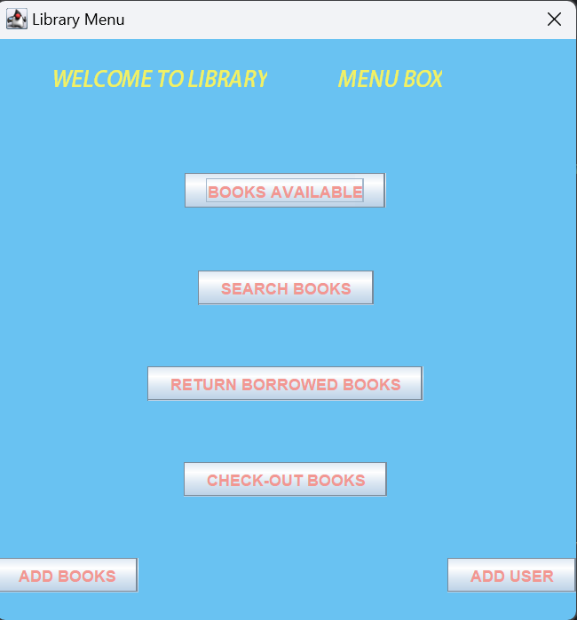

ADDING USERS:

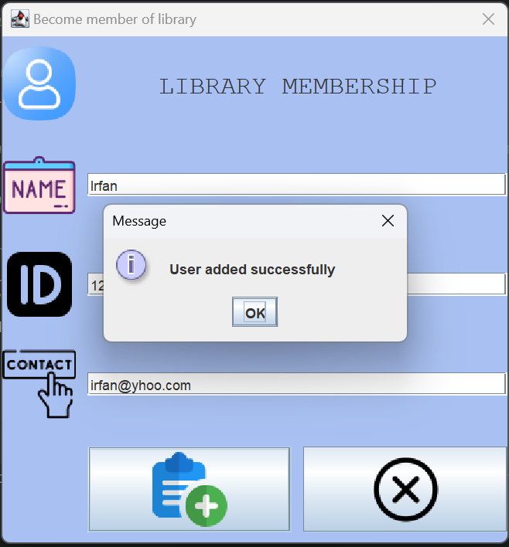

ADDING BOOKS:

DISPLAYING AVAILABLE BOOKS:

SEARCHING FOR BOOKS:

CHECKING OUT BOOK THAT IS BORROWED BY USER:

SEARCHING AND RETURNING BORROWED BOOKS:

**SOME DATABASE GUIDING SCREENSHOTS:**

* Open mySQL workbench, first use database you made , preferably make library named database to maintain naming consistency:

* Open SQL Script option:

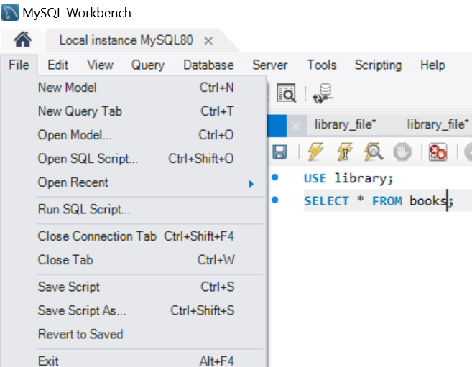

* CHOOSE THE DUMP FILE FROM REPOSITORY YOU CLONED:

* RUN SCRIPT:

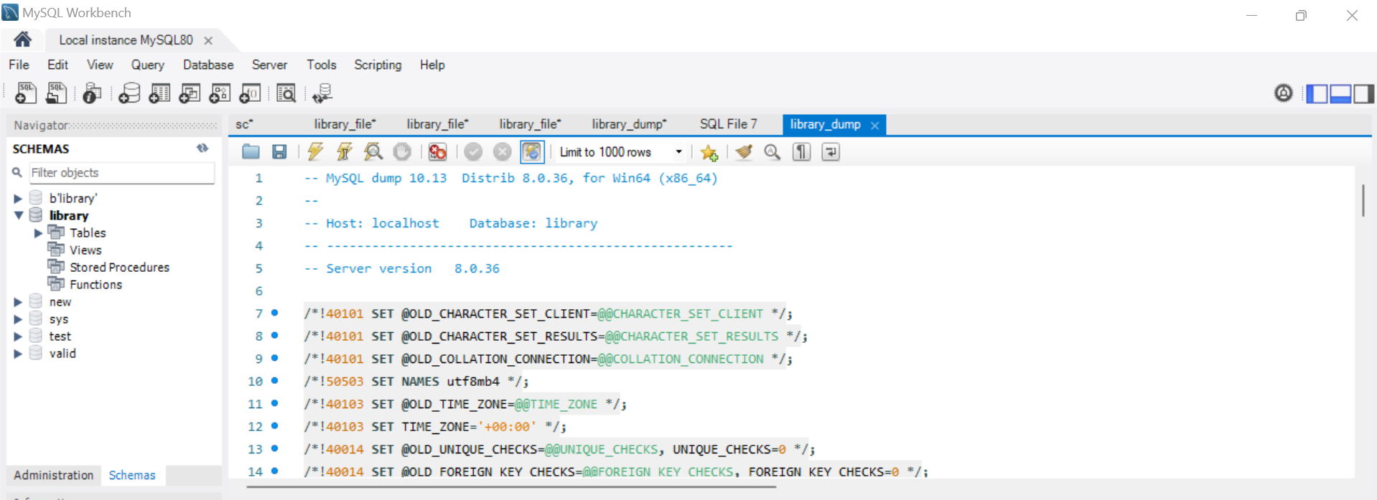

* When you clone, make sure you have them in directory:

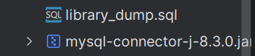

* Make this file and fill in your credentials, template is given , general form of URL would be something like:

jdbc:mysql://localhost:3306/library

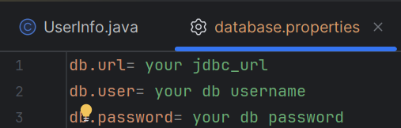

Now your project can run smoothly when you build.

GITHUB REPOSITORY LINK:

<https://github.com/nosherwantahir/CS212-Assignment-01.git>